The taijitu (太极图; 太極圖; tàijítú; commonly known as the "yin and yang **symbol**" or simply the "yin yang") and the bagua 八卦 ("Eight Trigrams") have importance in Taoist symbolism.

Hanyu Pinyin: Dàojiào

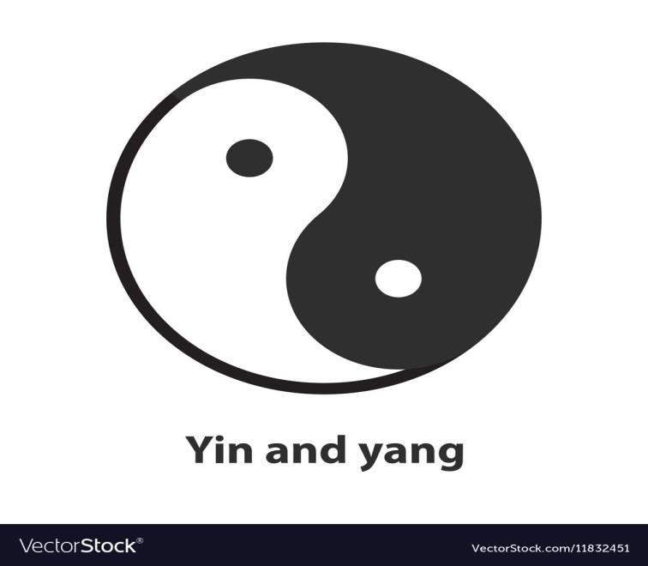

**Laozi**

**Lao-Tzu** (also known as **Laozi** or **Lao-Tze**) was a Chinese philosopher credited with founding the philosophical system of Taoism. He is best known as the author of the Tao-Te-Ching, the work which exemplifies his thought.Dec 20, 2012

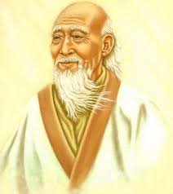

**Lao-tzu**

The key book of Taoism was compiled around the 3rd century BCE. It's called the Tao Te Ching (Dao De Jing or Daode Jing) - The Way and Its Power, and is also known as the Lao-tzu.Nov 12, 2009

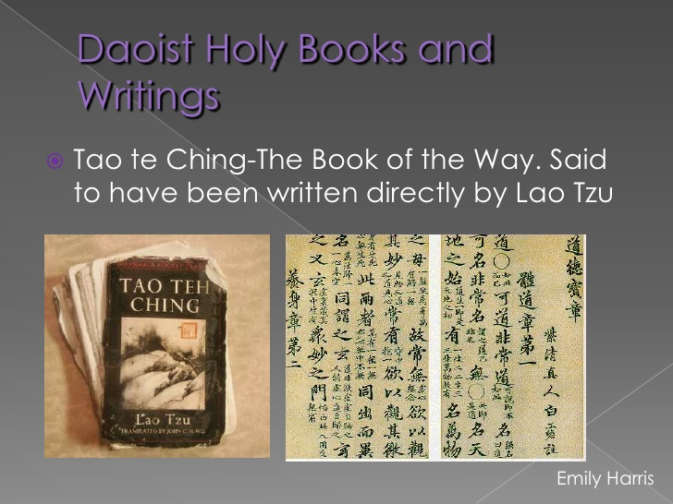

Like most philosophies or religions, Taoism has its very own canon, or collection of sacred texts. The most important text of Taoism is the Tao-te Ching. Believed to be authored by Lao-tzu, the first man to receive the inspiration of the Tao, these texts have no definitive date of origin.

[[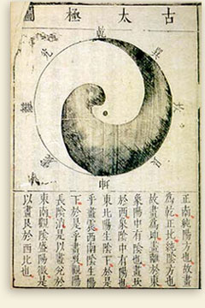](https://www.google.com/url?sa=i&rct=j&q=&esrc=s&source=images&cd=&ved=2ahUKEwi96su9wITlAhWB3mEKHWSMA0IQjRx6BAgBEAQ&url=http%3A%2F%2Fdaoismkatie.weebly.com%2Fsacred-texts.html&psig=AOvVaw0TKiiCVi1tks6hHD9eXTCb&ust=1570343750126571)](https://www.google.com/url?sa=i&rct=j&q=&esrc=s&source=images&cd=&ved=2ahUKEwi96su9wITlAhWB3mEKHWSMA0IQjRx6BAgBEAQ&url=http%3A%2F%2Fdaoismkatie.weebly.com%2Fsacred-texts.html&psig=AOvVaw0TKiiCVi1tks6hHD9eXTCb&ust=1570343750126571" \t "_blank)

Chinese philosophy to signify the fundamental or true nature of the world: simplicity and selflessness in conformity with the Tao, leading a life of non-purposive action, a life expressing the essence of spontaneity.. Taoism, also known as Daoism, arose about the same time as Confucianism.

Three to seven centuries after they were supposed to have lived, Han dynasty (around 100 BCE) historians identified Laozi and Zhuangzi as Daoists. ... When the Han Dynasty began trying to reconstruct China's classical history , its historians coined the term “Daoism,” probably thinking of Huang-Lao content.Feb 19, 2003

Daoism, also spelled Taoism, indigenous religio-philosophical tradition that has shaped Chinese life for more than 2,000 years. In the broadest sense, a Daoist attitude toward life can be seen in the accepting and yielding, the joyful and carefree sides of the Chinese character, an attitude that offsets and complements the moral and duty-conscious, austere and purposeful character ascribed to Confucianism. Daoism is also characterized by a positive, active attitude toward the occult and the metaphysical (theories on the nature of reality), whereas the agnostic, pragmatic Confucian tradition considers these issues of only marginal importance, although the reality of such issues is, by most Confucians, not denied.

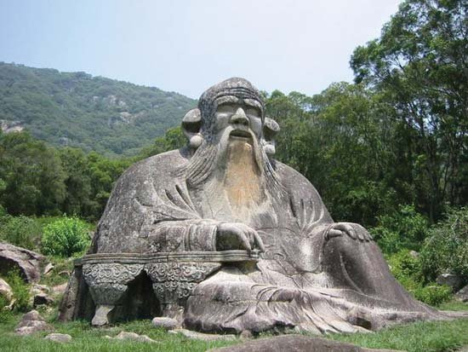

Taoism (/ˈdaʊɪzəm/, /ˈtaʊ-/), or Daoism (/ˈdaʊ-/), is a philosophical or religious tradition of Chinese origin which emphasises living in harmony with the Tao (Chinese: 道; pinyin: Dào; literally: 'the Way', also romanised as Dao). The Tao is a fundamental idea in most Chinese philosophical schools; in Taoism, however, it denotes the principle that is the source, pattern and substance of everything that exists.[2][3] Taoism differs from Confucianism by not emphasising rigid rituals and social order, but is similar in the sense that it is a teaching about the various disciplines for achieving "perfection" by becoming one with the unplanned rhythms of the universe called "the way" or "dao".[2][4] Taoist ethics vary depending on the particular school, but in general tend to emphasise wu wei (action without intention), "naturalness", simplicity, spontaneity, and the Three Treasures: 慈 "compassion", 儉 "frugality", and 不敢為天下先 "humility".

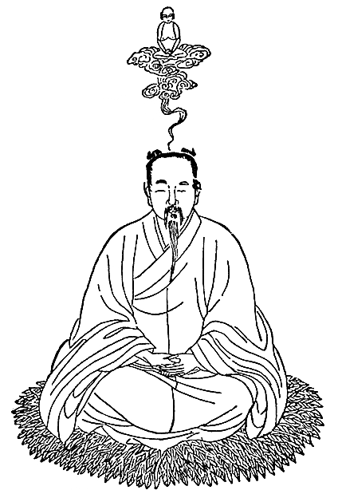

**Lord Lao**

Lord Lao, first known as the philosopher Laozi, the purported author of the Daode jing, later became an immortal, a messiah, and high god of Daoism.

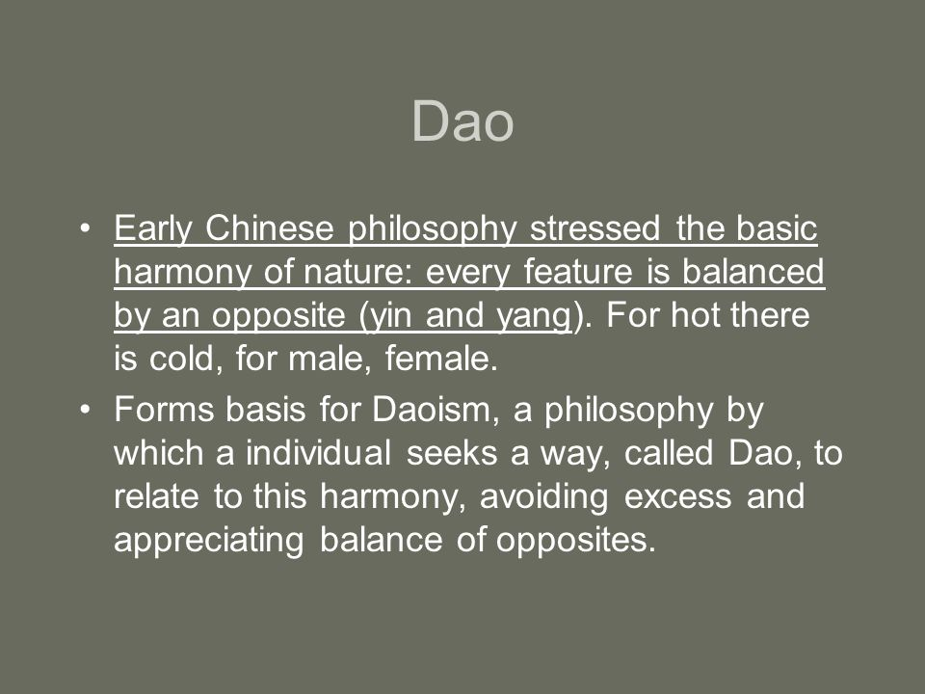

**The Tao-Te-Ching**

The Tao-Te-Ching is an attempt to remind people everyone could live together peacefully if people would only be mindful of how their thoughts and actions affect themselves, others, and the earth.

The Tao-Te-Ching is not a 'scripture' in any way. It is a book of poetry presenting the simple way of following the Tao and living life at peace with one's self, others, and the world of changes. A typical verse advises, "Yield and overcome/Empty and become full/Bend and become straight" to direct a reader to a simpler way of living. Instead of fighting against life and others, one can yield to circumstances and let the things which are not really important go. Instead of insisting one is right all the time, one can empty one's self of that kind of pride and be open to learning from other people. Instead of clinging to old belief patterns and hanging onto the past, one can bend to new ideas and new ways of living.

The Tao Te Ching, along with the Zhuangzi, is a fundamental text for both philosophical and religious Taoism. It also strongly influenced other schools of Chinese philosophy and religion, including Legalism, Confucianism, and Buddhism, which was largely interpreted through the use of Taoist words and concepts when it was originally introduced to China. Many artists, including poets, painters, calligraphers, and gardeners, have used the Tao Te Ching as a source of inspiration. Its influence has spread widely outside East Asia and it is among the most translated works in world literature.[7]

[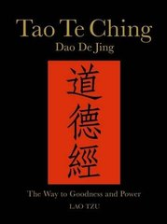](https://www.google.com/url?sa=i&rct=j&q=&esrc=s&source=images&cd=&ved=2ahUKEwj9-7HJxITlAhXF7WEKHb9AA3QQjRx6BAgBEAQ&url=https%3A%2F%2Fwww.fullybookedonline.com%2Fproducts%2Ftao-te-ching-dao-de-jing-the-way-to-goodness-and-power%3Ftaxon_id%3D122&psig=AOvVaw3S45tani1NB1ay01Xr60W2&ust=1570344837982474)

[[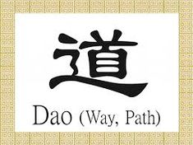](https://www.google.com/url?sa=i&rct=j&q=&esrc=s&source=images&cd=&ved=2ahUKEwjggJX0xITlAhWR7WEKHYduC38QjRx6BAgBEAQ&url=https%3A%2F%2Fwww.pinterest.com%2Fmastercraftsmanjrussell9883%2Fdaoism%2F&psig=AOvVaw3wpxPVgfGJ7KYUPg6YMN9o&ust=1570344931399331)](https://www.google.com/url?sa=i&rct=j&q=&esrc=s&source=images&cd=&ved=2ahUKEwj9-7HJxITlAhXF7WEKHb9AA3QQjRx6BAgBEAQ&url=https%3A%2F%2Fwww.fullybookedonline.com%2Fproducts%2Ftao-te-ching-dao-de-jing-the-way-to-goodness-and-power%3Ftaxon_id%3D122&psig=AOvVaw3S45tani1NB1ay01Xr60W2&ust=1570344837982474" \t "_blank)

[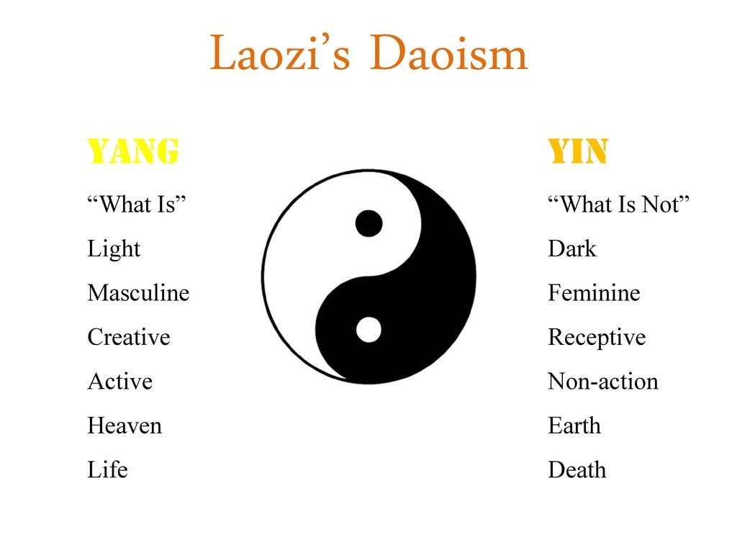](https://www.google.com/url?sa=i&rct=j&q=&esrc=s&source=images&cd=&ved=2ahUKEwjggJX0xITlAhWR7WEKHYduC38QjRx6BAgBEAQ&url=https%3A%2F%2Fwww.pinterest.com%2Fmastercraftsmanjrussell9883%2Fdaoism%2F&psig=AOvVaw3wpxPVgfGJ7KYUPg6YMN9o&ust=1570344931399331" \t "_blank)